Data Structure

The data structure name indicates itself that organizing the data in memory. There are many ways of organizing the data in the memory as we have already seen one of the data structures, i.e., array in C language. Array is a collection of memory elements in which data is stored sequentially, i.e., one after another. In other words, we can say that array stores the elements in a continuous manner. This organization of data is done with the help of an array of data structures. There are also other ways to organize the data in memory. Let's see the different types of data structures.The data structure is not any programming language like C, C++, java, etc. It is a set of algorithms that we can use in any programming language to structure the data in the memory.
To structure the data in memory, 'n' number of algorithms were proposed, and all these algorithms are known as Abstract data types. These abstract data types are the set of rules.
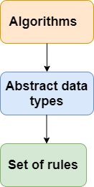

Types of Data Structures

There are two types of data structures:
- Primitive data structure
- Non-primitive data structure
Primitive Data structure
The primitive data structures are primitive data types. The int, char, float, double, and pointer are the primitive data structures that can hold a single value.
Non-Primitive Data structure
The non-primitive data structure is divided into two types:
- Linear data structure
- Non-linear data structure

Linear Data Structure
The arrangement of data in a sequential manner is known as a linear data structure. The data structures used for this purpose are Arrays, Linked list, Stacks, and Queues. In these data structures, one element is connected to only one another element in a linear form.
When one element is connected to the 'n' number of elements known as a non-linear data structure. The best example is trees and graphs. In this case, the elements are arranged in a random manner.
We will discuss the above data structures in brief in the coming topics. Now, we will see the common operations that we can perform on these data structures.

Data structures can also be classified as:
- Static data structure: It is a type of data structure where the size is allocated at the compile time. Therefore, the maximum size is fixed.
- Dynamic data structure: It is a type of data structure where the size is allocated at the run time. Therefore, the maximum size is flexible.

Major Operations
The major or the common operations that can be performed on the data structures are:
- Searching: We can search for any element in a data structure.
- Sorting: We can sort the elements of a data structure either in an ascending or descending order.
- Insertion: We can also insert the new element in a data structure.
- Updation: We can also update the element, i.e., we can replace the element with another element.
- Deletion: We can also perform the delete operation to remove the element from the data structure.

Advantages of Data structures
The following are the advantages of a data structure:
- Efficiency: If the choice of a data structure for implementing a particular ADT is proper, it makes the program very efficient in terms of time and space.
- Reusability: The data structure provides reusability means that multiple client programs can use the data structure.
- Abstraction: The data structure specified by an ADT also provides the level of abstraction. The client cannot see the internal working of the data structure, so it does not have to worry about the implementation part. The client can only see the interface.

Data Structure Classification

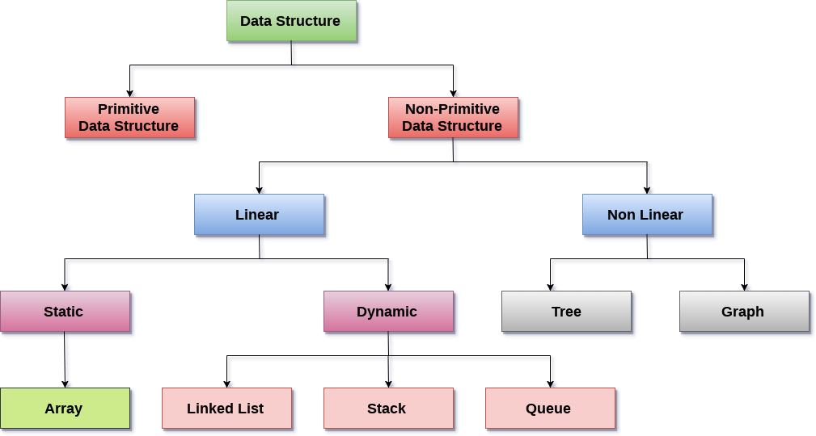

Linear Data Structures: A data structure is called linear if all of its elements are arranged in the linear order. In lineged in sequenged in sequenged in sequenged in sequenged in sequenged in sequenged in sequenged in sequenged in sequenged in sequenged in sequenged in sequenar data structures, the elements are stored in non-hierarchical way where each element has the successors and predecessors except the first and last element.
Types of Linear Data Structures are given below:
Arrays: An array is a collection of similar type of data items and each data item is called an element of the array. The data type of the element may be any valid data type like char, int, float or double.
The elements of array share the same variable name but each one carries a different index number known as subscript. The array can be one dimensional, two dimensional or multidimensional.
The individual elements of the array age are:
age[0], age[1], age[2], age[3],......... age[98], age[99].
Linked List: Linked list is a linear data structure which is used to maintain a list in the memory. It can be seen as the collection of nodes stored at non-contiguous memory locations. Each node of the list contains a pointer to its adjacent node.
Stack: Stack is a linear list in which insertion and deletions are allowed only at one end, called top.
A stack is an abstract data type (ADT), can be implemented in most of the programming languages. It is named as stack because it behaves like a real-world stack, for example: - piles of plates or deck of cards etc.
Queue: Queue is a linear list in which elements can be inserted only at one end called rear and deleted only at the other end called front.
It is an abstract data structure, similar to stack. Queue is opened at both end therefore it follows First-In-First-Out (FIFO) methodology for storing the data items.
Non Linear Data Structures: This data structure does not form a sequence i.e. each item or element is connected with two or more other items in a non-linear arrangement. The data elements are not arranged in sequential structure.
Types of Non Linear Data Structures are given below:
Trees: Trees are multilevel data structures with a hierarchical relationship among its elements known as nodes. The bottommost nodes in the herierchy are called leaf node while the topmost node is called root node. Each node contains pointers to point adjacent nodes.
Tree data structure is based on the parent-child relationship among the nodes. Each node in the tree can have more than one children except the leaf nodes whereas each node can have atmost one parent except the root node. Trees can be classfied into many categories which will be discussed later in this tutorial.
Graphs: Graphs can be defined as the pictorial representation of the set of elements (represented by vertices) connected by the links known as edges. A graph is different from tree in the sense that a graph can have cycle while the tree can not have the one.

Operations on data structure
1) Traversing: Every data structure contains the set of data elements. Traversing the data structure means visiting each element of the data structure in order to perform some specific operation like searching or sorting.
Example: If we need to calculate the average of the marks obtained by a student in 6 different subject, we need to traverse the complete array of marks and calculate the total sum, then we will devide that sum by the number of subjects i.e. 6, in order to find the average.
2) Insertion: Insertion can be defined as the process of adding the elements to the data structure at any location.
If the size of data structure is n then we can only insert n-1 data elements into it.
3) Deletion:The process of removing an element from the data structure is called Deletion. We can delete an element from the data structure at any random location.
If we try to delete an element from an empty data structure then underflow occurs.
4) Searching: The process of finding the location of an element within the data structure is called Searching. There are two algorithms to perform searching, Linear Search and Binary Search. We will discuss each one of them later in this tutorial.
5) Sorting: The process of arranging the data structure in a specific order is known as Sorting. There are many algorithms that can be used to perform sorting, for example, insertion sort, selection sort, bubble sort, etc.
6) Merging: When two lists List A and List B of size M and N respectively, of similar type of elements, clubbed or joined to produce the third list, List C of size (M+N), then this process is called merging

